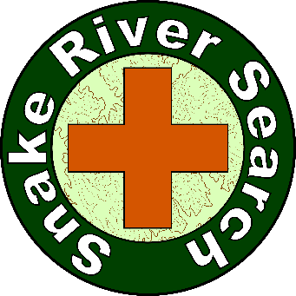**Snake River Search, Inc. (SRS)  
Small Unmanned Aircraft System (sUAS)  
Roles & Responsibilities**

**SRS sUAS Roles:**

* Mission Pilots (PICs & PMCs)
* Visual Observers
* Scanners
* Image Analysts
* Aerial Photographers

**Mission Pilots:  
Pilots in Command (PICs) & Pilots Manipulating Controls (PMCs)**

* There are two types of Mission Pilots: A Pilot in Command (PIC) and a Pilot Manipulating Controls (PMC). The PIC must have an FAA Remote Pilot Certificate with sUAS Rating. The PMC does not have to be certificated/rated, but must be operated under the direct supervision of a certified/rated PIC. The PIC may also be the PMC.
* During flight operations, the PIC is in complete command of the aircraft and all flight crewmembers, including PMCs, Visual Observers, Scanners, and Aerial Photographers (but not necessarily post-mission Image Analysts).
* A PIC may be responsible for and a PMC may fly only one aircraft at a time.
* There may be an Incident Commander or an Air Operations Manager who has authority over the search mission and will make specific assignments and establish rules of engagement. However, the PIC is ultimately responsible for the safety of his crew and aircraft, as well as compliance with FAA rules and regulations. The PIC always has the final say in any Go/No-Go decisions involving the safe and proper use of his crew and aircraft.
* The first and foremost duty of a Mission Pilot is to fly the aircraft in a safe and proficient manner, following all applicable FAA rules and regulations.
* Mission Pilots must remember that they are not Scanners. A Mission Pilot who tries to fly the aircraft and scan the search area at the same time is doing neither job effectively or safely.
* The Mission Pilot’s contribution to a successful search is his ability to fly the search pattern precisely and effectively, while maintaining altitude and airspeed, in order to place the Scanners’ eyes over the search area so they can do their job.
* The Mission Pilot is responsible for ensuring the safety of the crew, aircraft, and others. The Mission Pilot must maintain visual line of sight (LOS) to the aircraft, to "see and avoid" obstacles and other aircraft.
* The Mission Pilot is responsible for incorporating Operational Risk Management and Crew Resource Management principles and practices into each mission.
* The Mission Pilot is responsible for getting proper briefings and for planning the sortie, but should include the other crewmembers during these activities.

**Visual Observers (VOs)**

The Visual Observer’s primary mission role is assisting the Mission Pilot in maintaining visual LOS to the aircraft, and avoiding collisions and obstacles. Additional assistance may be provided in the planning phase, handling radio communications, and record keeping. Specific duties include:

* Attend briefings with the Mission Pilot.
* Assist in planning the mission.
* Assist in setting up the aircraft and operating radios.
* Maintain situational awareness at all times.
* Assist the Mission Pilot in maintaining visual LOS.
* Assist in avoiding collisions and obstacles.
* Maintain a chronological flight log of all observations of note, including precise locations, and any other noteworthy information, as provided by the Mission Pilot or the Scanner. Include such things as other aircraft, ground parties, descriptive information concerning the search area, weather conditions (e.g., sun position, clouds, and search visibility), and possible sightings. Note: The Mission Pilot or another Visual Observer must have visual LOS to the aircraft while the Visual Observer is logging mission data.

Once airborne, the Visual Observers watches the sky, maintaining eye contact with the aircraft and surrounding aerial scene. Although binoculars may be used to enhance vision and situational awareness, the aircraft must remain visible without the aid of the binoculars.

**Scanners**

The Scanner’s primary mission role is effective visual search. “Scanning” is a method of looking for the subject of the search in an assigned area in a systematic way. Specific duties include:

* Attend briefings with the Mission Pilot.
* Assist in planning the mission.
* Assist in setting up the aircraft and operating radios.
* Maintain situational awareness at all times.
* Assist in navigating the aircraft.
* Assist in monitoring fuel/battery status.
* Employ effective scanning techniques.
* Report and/or record all sightings to include the time and geographical location. Include such things as ground parties, descriptive information concerning the search area, and possible sightings. Visual Observers may assist in recording information reported by the Scanners.

Once airborne and over the search area, the Scanners maintain constant observation of the ground scene, via real-time video display.

**Image Analysts**

Image Analysts turn the raw collected data into useful decision-making data.

* During the mission flight, the Scanners serve as real-time Image Analysts.
* After the mission, Image Analysts review, process, and interpret the video and photo imagery collected during the mission, integrating it with recorded flight data and digital maps.
* Mission Pilots, Visual Observers, Scanners, and Aerial Photographers may all assist or even serve as post-mission Image Analysts, as far as reviewing and interpreting imagery.
* A real Image Analyst, however, should be proficient with digital mapping software, video processing software, photo processing software, and data logger conversion and integration software. A real Image Analyst should also be proficient with, or at lease familiar with, Photogrammetry.

**Aerial Photographers**

The Aerial Photographer is responsible for collecting Aerial Imagery (video and/or photo) during the mission flight. With many sUASs, the Mission Pilot must also be the Aerial Photographer, because the camera and gimbal are integrated with the aircraft flight controls. Some UAVs, however, have a camera and gimbal that can be operated independently of the aircraft flight controls. In this case, a separate Aerial Photographer may be assigned. The Scanner may also serve as the Aerial Photographer, if knowledgeable and proficient with the gimbal/camera system. Alternatively, the Aerial Photographer may also serve as a Scanner.

Once airborne and over the search area, the Aerial Photographers operate the gimbal and camera controls to collect the video and/or photo Aerial Imagery.

**Wings**

* Certified/Rated PICs may wear the SRS PIC Wings.

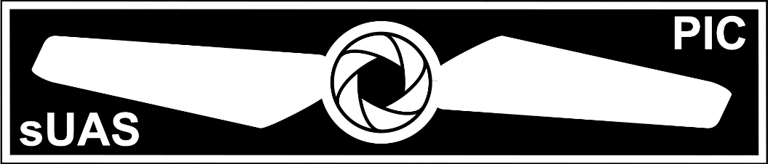

* All other crewmembers (PMCs, Visual Observers, Scanners, Image Analysts, and Aerial Photographers) may earn the privilege of wearing the SRS Crew Wings, by passing the exam for the FAA on-line Course ALC-451 – Part 107 sUAS.

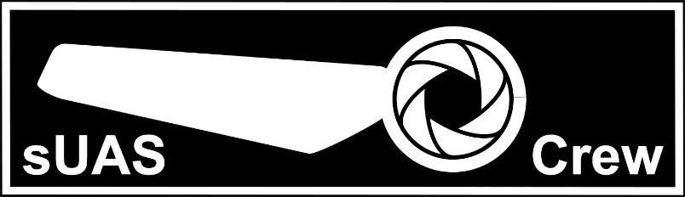

* All PICs and crewmembers, but especially those awarded wings, are expected to participate in regular aviation training, to develop and maintain proficiency in the essential aviation knowledge and skills, and to learn to work as a coordinated and effective team.

**Proficiency Training**

* **PICs:**
  + Earn FAA Remote Pilot Certificate with sUAS Rating
  + Learn the aircraft system and controls and fly often (log flight-time)
  + Attend regular SRS sUAS Team training exercises
* **PMCs:**
  + Become familiar with Part 107 (Pass on-line Part 107 exam, to wear Crew Wings)
  + Learn the aircraft system and controls and fly often
  + Attend regular SRS sUAS Team training exercises
* **Visual Observers:**
  + Become familiar with Part 107 (Pass on-line Part 107 exam, to wear Crew Wings)
  + Develop radio communications skills
  + Attend regular SRS sUAS Team training exercises
* **Scanners:**
  + Become familiar with Part 107 (Pass on-line Part 107 exam, to wear Crew Wings)
  + Attend SRS Scanner Training
  + Learn the in-flight video systems and use them often
  + Attend regular SRS sUAS Team training exercises
* **Image Analysts**
  + Become familiar with Part 107 (Pass on-line Part 107 exam, to wear Crew Wings)
  + Attend SRS Scanner Training
  + Learn the mapping and image analysis software packages and use them often
  + Attend regular SRS sUAS Team training exercises
* **Aerial Photographers**
  + Become familiar with Part 107 (Pass on-line Part 107 exam, to wear Crew Wings)
  + Study photography, learn the camera/gimbal system operations, and use them often
  + Attend SRS Scanner Training
  + Attend regular SRS sUAS Team training exercises

**Mission Data**

Mission Data may include both: (1) Aerial Imagery (video and/or photos) and (2) Flight Data, including GPS tracks and other logged flight parameters (e.g., altitude, yaw, pitch, roll, etc).

Aerial Imagery and Flight Data acquired on a training mission is the property of the sUAS owner, but should be shared with SRS for training or publicity efforts.

Aerial Imagery acquired for a customer, during a search mission, is the property of the customer. It may not be used for ANY reason (including training or publicity) without the expressed written consent of the customer.

Flight Data acquired during a search mission is the property of the sUAS owner, but should be shared with the customer, upon request, and with SRS for training or publicity efforts.